Experiment 5 – LTE-Advanced Carrier Aggregation
Aim
To simulate an LTE-Advanced link with carrier aggregation and compare aggregated bandwidth and estimated throughput.
Procedure
- Open MATLAB and define carrier bandwidth and spectral efficiency.
- Calculate throughput for one component carrier.
- Calculate and plot throughput for one, two and three aggregated carriers.
- Compare throughput for carrier bandwidths of 5, 10, 15 and 20 MHz.
Objective – 1: Model One Component Carrier
clc; clear; close all;
BW1 = 20; SE = 4; Ncc = 1;
BWagg = BW1*Ncc;
Throughput = BWagg*SE;
fprintf('Bandwidth = %.0f MHz\n',BWagg);
fprintf('Estimated throughput = %.0f Mbps\n',Throughput);
figure; bar(Ncc,Throughput); grid on;
xlabel('Number of component carriers'); ylabel('Throughput (Mbps)');
title('Single Carrier Throughput');
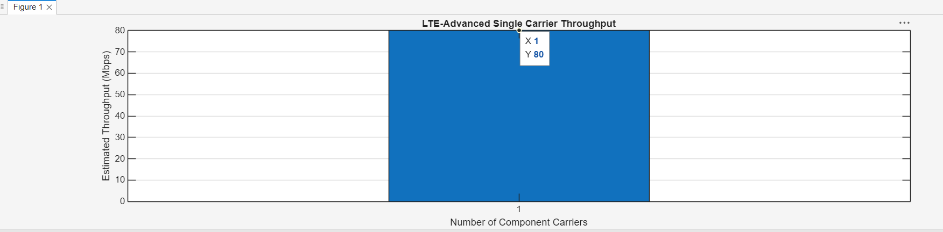

Objective – 2: Extend to Multiple Aggregated Component Carriers
MATLAB PROGRAM
clc; clear; close all;
BWcc = 20; SE = 4; CC = [1 2 3];
AggBW = BWcc.*CC; TP = AggBW.*SE;
disp(table(CC',AggBW',TP','VariableNames',{'Carriers','Bandwidth_MHz','Throughput_Mbps'}));
figure; bar(CC,TP); grid on;
xlabel('Number of aggregated carriers'); ylabel('Throughput (Mbps)');
title('Carrier Aggregation Throughput');
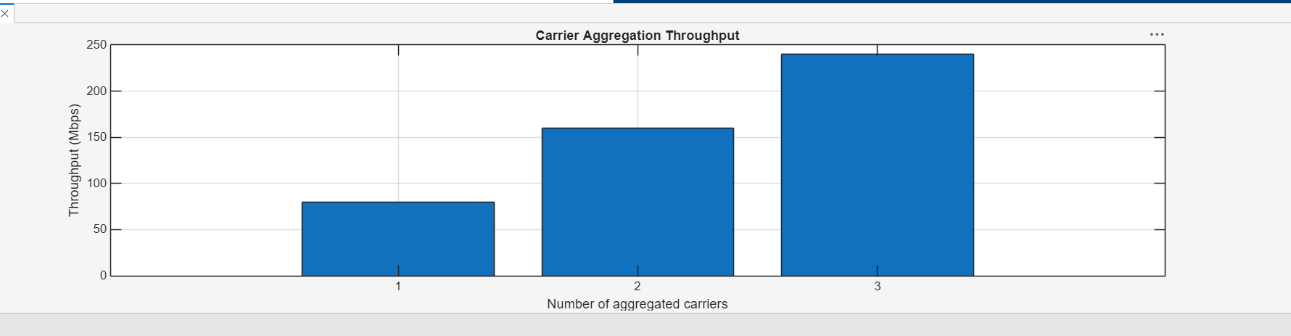
Objective – 3: Compare Estimated Throughput for Different Carrier Bandwidths
MATLAB PROGRAM
clc; clear; close all;
BW = [5 10 15 20]; SE = 4; TP = BW.*SE;
disp(table(BW',TP','VariableNames',{'Bandwidth_MHz','Throughput_Mbps'}));
figure; plot(BW,TP,'o-','LineWidth',2); grid on;
xlabel('Carrier bandwidth (MHz)'); ylabel('Throughput (Mbps)');
title('Throughput versus Bandwidth');
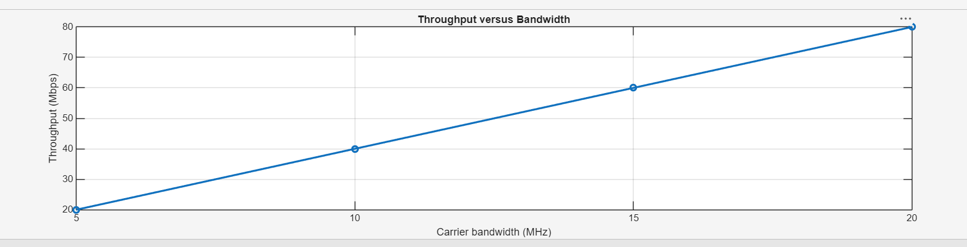

Result
The model showed that estimated throughput increases with aggregated bandwidth. With 4 bits/s/Hz, 20 MHz gives 80 Mbps; two and three 20 MHz carriers give 160 and 240 Mbps under this simplified model.

